**NarcoTech**

**Project Management Plan**

**Alexa Physio Reminder Skill**

**Appointment Reminder System for O.P.S**

**Team Members Contact**

Tarika Birch (PRO) tarika.birch@mycavehill.uwi.edu

Dwayne Archer dwayne.archer@mycavehill.uwi.edu

Kai Hill kai.hill@mycavehill.uwi.edu

Aaron Grimes aaron.grimes@mycavehill.uwi.edu

Kelilah Mayers kelilah.mayers@mycavehill.uwi.edu

Table of Contents

Introduction 3

Objectives 3

Project Scope 4

1. Provide Appointment Reminders 4

2. Provide Appointment Schedule Information 4

3. Update Appointment Information 4

Constraints 4

Project Structure 5

Team Structure 5

Team Members 6

Software Development Methodology 7

Project Schedule 8

Estimated Task Time 8

Gantt Chart 8

Deliverables 9

Milestones 9

Cost Structure 9

Resource Management 10

Risk Management 11

1. Poor Code Quality 11

2. Time Constraints 11

3. Scope Creep 11

4. Team Member Availability 12

5. Technical Challenges 12

Monitoring and Reporting 13

Progress Tracking 13

Key Performance Indicators (KPI) 14

Report Strategy 15

Documentation Strategy 15

# Introduction

The management at Optimal Physiotherapy Services (O.P.S.) has recognized a gap in rehabilitative care throughout the island. As such, the organization has decided to implement an OPS App Suite which aims to be a centralized hub for software solutions, catering to the needs of patients in rehabilitative care. One of these needs, as identified by our team at NarcoTech, involves the management of patients’ physiotherapy appointments. As such, it is our aim to provide a forward-thinking solution, designed to assist patients in this aspect of the rehabilitation process.

**Problem Statement**

Optimal Physiotherapy Services (O.P.S) has identified a critical gap in patient care throughout the island, specifically concerning the support provided during their patients' rehabilitation process. Our team at NarcoTech has observed a common challenge among older individuals dealing with Repetitive Strain Injury (RSI) in the Achilles Tendon. These individuals tend to have difficulty managing their physiotherapy sessions. This stems from difficulty remembering booked appointments with their physical therapists. The aforementioned issue can lead to missed physiotherapy sessions, potentially extending patients’ recovery, and resulting in prolonged post-rehabilitative care. This highlights a pressing need for streamlined and user-friendly solutions to enhance the patient's experience and improve overall recovery times.

**Problem Solution**

In order to reduce the number of missed appointments and enhance the overall patient recovery experience, an Alexa skill should be developed to keep users abreast of their upcoming appointments. This skill will allow users to remain informed about scheduled appointments with their physiotherapists at O.P.S, ensuring they never miss out on their physiotherapy sessions unnecessarily. The Physio Reminder skill will provide users with a convenient and hands-free method of staying on top of their appointments. Implementing this approach will not only benefit users but will also improve operational efficiency at O.P.S. by minimizing unused appointment times.

# Objectives

The purpose of the Alexa skill is to streamline the appointment scheduling process. To accomplish this, the Alexa skill will:

* **Reduce Missed Appointments:** The implementation of this system will help patients remember and manage their physiotherapy appointments
* **Improve Recovery Times:** The solution should reduce the extended recovery times due to missed appointments
* **Ease of Confirmation:** The proposed system will make it easier for clients to double check when their next appointment is scheduled so they can keep track of when next they need to go to physiotherapy.

# Project Scope

The purpose of the Physio Reminder skill is to streamline the appointment scheduling process. To accomplish this, the Alexa skill will:

## Provide Appointment Reminders

The skill will send appointment reminders to the users, allowing them to remain informed about upcoming sessions.

## Provide Appointment Schedule Information

The skill will provide patients with real-time information regarding their booked appointments, allowing them to keep track of their upcoming appointments. This information will include the date and time of the scheduled session as well as the physiotherapist assigned.

## Update Appointment Information

The skill will allow users to create, delete and update reminders, allowing them to ensure that their appointment details are always relevant and up to date.

# Constraints

1. **Time**: Skill must be fully developed and tested within 4 weeks.
2. **Hardware:** The skill will require an Alexa-enabled device with a working microphone and speaker. Some examples of these devices include:
   1. Alexa Echo Devices
   2. Smart Home Devices
   3. Phone/Tablet
   4. Computer
3. **Internet Connectivity:** Users will need a stable internet connection in order for the skill to function properly.
4. **Privacy & Security:** The Alexa skill should not reveal an individual’s schedule information to other users. The skill design should be privacy conscious and implement data hiding, such that:
   1. Users of skill must not be able to access the client’s or other users’ data.
   2. Client must not be able to access users’ data.
5. **Usability:** The skill should be user-friendly, keeping in mind that the users are of an older age range and need high levels of accessibility.
6. **Voice Interaction:** The skill's functionality is limited to voice interactions, which may pose constraints for users with hearing or speech impairments.

# Project Structure

## Team Structure

In this project, a democratic team structure of 5 individuals has been chosen, where each team member's role aligns with their individual strengths and skillsets. This approach has been chosen to ensure the full potential of the team is realized throughout the project’s lifecycle. This will ensure that the best composition of members is used to the advantage of the project. The approach promotes collaboration between the members, where important decisions are made by consensus, fostering a well-rounded and inclusive approach to project management.

**Democratic Team Organization

Team Member

Communication Link

The team will be comprised of 5 members, however given the time constraints of the project, each member has been assigned 2 roles to facilitate collaboration and assist in speeding up the workflow. This will also ensure that in the absence of a team member, there will be others with the knowledge and capabilities to fill this gap. The team will consist of:

* 1 Project Manager
* 1 Product Manager
* 1 Public Relations Officer
* 2 Software Engineers
* 2 Documentalists
* 2 Marketing & Sales Personnel
* 1 Quality Assurance Specialist

## Team Members

**Tarika Birch – Project Manager, Public Relations Officer**

As Project Manager, Tarika Birch will be responsible for overseeing all aspects of the project, ensuring that objectives are met within the scheduled timeframe and established budget. She will plan the activities associated with the project and monitor the overall progress of the project. As the Public Relations Officer, Ms. Birch will also be responsible for communicating with stakeholders on behalf of the team. She will ensure that all relevant information is relayed to the appropriate personnel in a timely manner.

**Kelilah Mayers – Quality Assurance Specialist, Product Manager**

As a Product Manager, Kelilah Mayers essentially will act as an advocate for customers to ensure the customers’ requirements are fulfilled and on time. Ms. Mayers will also operate as the Quality Assurance Specialist, meaning that she will be responsible for the validation and verification aspects of the project. Her role will involve the creation and execution of tests to ensure that the quality of the final project upholds a certain standard.

**Kai Hill – Software Engineer, Documentalist**

As a Software Engineer, Kai Hill’s role revolves around the design and implementation of both the front-end and back-end components of the Alexa skill. He is responsible for devising practical solutions that meet the specifications of the project and executing the implementation. He also plays a part in the documentation of the software, including the in-code documentation and the user manual.

**Dwayne Archer – Software Engineer, Marketing and Sales**

As a Software Engineer, Dwayne Archer’s roles and responsibilities are developing, designing, and maintaining the front-end and back-end components of the Alexa skill. He is involved in the execution of the project objectives and will provide comprehensive documentation on the software code that will be written. As a Marketing and Salesperson, he will be involved in the creation of a marketing plan and making sure that the final product is desirable to the target audience. In addition, he is a second-year student at the University of the West Indies in the field of Computer Science.

**Aaron Grimes – Marketing and Sales, Documentalist**

As a Marketing and Salesperson, Aaron Grimes will be responsible for developing the marketing plan, ensuring the product meets the needs of the target market and assisting with any advertising creatives. As a Documentalist, he will ensure the team’s work is well organized and documented accordingly. Aaron is a third-year student pursuing an Information Technology and Management degree at the University of the West Indies and is the Chief Operations Officer of a digital marketing company known as Inova Media.

## Software Development Methodology

Throughout the development of this skill, the team will make use of the Prototyping Software Process Model. This iterative approach will involve the creation of an early, incomplete version of the skill using JavaScript on the developer’s local machine and storing the data in JSON files. Following the development of this prototype, the system will be evaluated, refined and improved until the client’s requirements are met. The rationale behind using this model is as follows:

* **Flexibility:** The prototype model allows for easy adaptation to changing requirements and other necessary adjustments throughout the development process. Due to the limited time to produce a final product, flexibility will be necessary to ensure that objectives can be met in the event of a delayed schedule or other unforeseen circumstances.
* **Risk Mitigation:** Prototyping assists with the identification of potential issues or challenges early on in the development process. By evaluating a working model, our team can address concerns, mitigate risks, and make informed decisions before tackling full-scale development.
* **User Experience (UX) Design:** The success of the skill is heavily dependent on a positive user experience. Prototyping allows for refinement of the user interface, ensuring it is intuitive, easy to use, and aligns with the needs of older individuals dealing with Repetitive Strain Injury (RSI).
* **Continuous Improvement:** Prototyping encourages continuous improvement. Each iteration will allow room for enhancement, ensuring that the final skill is optimized for user satisfaction.

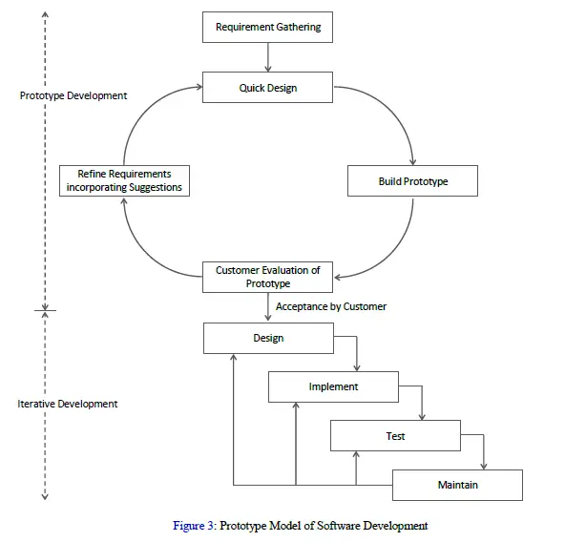

Figure . Prototype Model

# Project Schedule

## Estimated Task Time

|  |  |
| --- | --- |
| **Tasks** | **Estimated Time** |
| Client Consultation | 1 day |
| Requirements Criteria | 4 days |
| Design | 4 days |
| Implementation | 4 days |
| Marketing and Sales | 5 days |
| Quality Assurance | 5 days |
| Post Code Review | 2 days |
| Packaging & Delivery | 2 days |

## Gantt Chart

## Deliverables

|  |  |  |
| --- | --- | --- |
| Deliverable | Type | Date |
| Prototype | Internal | 18/10/23 |
| Specifications & Requirements | Internal | 27/10/23 |
| Marketing Plan | External | 01/11/23 |
| Design Documentation | Internal | 05/11/23 |
| Technical Manual | External | 10/11/23 |
| Source Code – Alpha Version | Internal | 11/11/23 |
| Testing Documentation | Internal | 14/11/23 |
| Source Code – Beta Version | Internal | 15/11/23 |
| User Manual | External | 17/11/23 |
| Project Logbook | Internal | 17/11/23 |
| Final Product (Developed Skill + Documentation) | External | 18/11/23 |

## Milestones

|  |  |  |
| --- | --- | --- |
| Milestone | Phase | Date |
| Project Start | Initialization | 02/10/23 |
| Finalized Requirements | Requirements | 14/10/23 |
| Final Design Delivery | Design | 06/11/23 |
| Skill Developed - Alpha Version | Implementation | 11/11/23 |
| Skill Reviewed – Beta Version | Testing | 15/11/23 |
| Product Delivered | Packaging | 18/11/23 |
| Project End | Closing | 18/11/23 |

# Cost Structure

|  |  |  |  |
| --- | --- | --- | --- |
| Tasks | Quality Hours | Cost / Hour ($BDS) | Estimated Cost ($BDS) |
| Requirements Criteria | 2 | 20 | 40 |
| Client Consultation | 2 | 0 | 0 |
| Design | 14 | 55 | 770 |
| Implementation | 20 | 65 | 1300 |
| Marketing and Sales | 16 | 25 | 400 |
| Quality Assurance | 4 | 20 | 80 |
| Post Code Review | 4 | 20 | 80 |
| Packaging & Delivery | 4 | 40 | 160 |
| Hardware & Software | | | 3500 |
| Marketing Budget | | | 3000 |
| Total Estimated Cost | | | 9330 |

# Resource Management

**Personnel Allocation**

The team will consist of 5 dedicated members. Each member will hold two (2) roles based on their individual skillsets. In the event that one member is unavailable, their counterpart for the shared role should be able to step in and assist in that area. This will be critical to the success of the project, given the time constraints and potentially heavy schedules of the individuals involved.

**Hardware Requirements**

The software engineers will use one (1) dedicated computer each for the duration of the project. The specifications of these computers are as follows:

* 8 Gb RAM
* 256 Gb Storage
* 2.5 GHz 4 Cores

In addition, the developers will require:

* Internet connection of at least 50mbps
* Functional Microphone
* Functional Speaker

**Software Requirements**

To facilitate the development of the Alexa Skill each developer will need access to the following:

* GitHub Repository for Version Control
* Amazon Developer Account
* AWS Services:
  + DynamoDB
  + Lambda
  + Identity & Access Management

Each team member will need access to the following:

* Microsoft Teams - Team Meetings, File Sharing & Collaboration
* Microsoft 365 - Document Creation & Editing

# Risk Management

During the lifecycle of the project, several factors may negatively impact or hinder the successful completion of the booking system. This section addresses some of the potential risks as well as the management strategies to mitigate these risks.

## Poor Code Quality

**Risk Identification -** The quality of any implementation has the potential to suffer for various reasons such as rushed work or gaps in knowledge.

**Risk Assessment -** Given the timeframe of this project, both of these factors are high risks to the quality of the final product. Our developers must learn quickly on the job while keeping up with very short deadlines.

**Risk Mitigation -** To combat these issues, we plan to undergo a rigorous testing process before the code is packaged and released to the client. The test criteria will be predefined based on the specifications of the project and tests will be performed to ensure the developed skill satisfies these criteria. Upon review, if any elements are found lacking, there will be a subsequent code review to fine tune the relevant areas.

**Risk Monitoring -** To ensure the effectiveness of our mitigation strategy, we will implement continuous monitoring of code quality along with the final testing strategy. This will involve ongoing peer reviews between the developers, as well as feedback from the Quality Assurance Specialist.

## Time Constraints

**Risk Identification -** The lifecycle of the project is extremely short. This means that our team will be working under severe time constraints.

**Risk Assessment -** Given the time constraints, this project will be moving at a very quick pace and is therefore highly susceptible to being incomplete if time is not managed correctly.

**Risk Mitigation -** In order to ensure the highest quality, the timelines should be clearly defined up front, allocating enough time for each project activity to be carried out. To ensure that everything is completed in a reasonable timeframe, a project schedule will be used outlining the various activities associated with the project.

**Risk Monitoring** - The project’s progress and timeline will be continuously monitored to ensure adequate alignment with the pre-defined schedule.

## Scope Creep

**Risk Identification -** Scope creep is a common risk where new project requirements may be added to the scope after execution has begun. This project, while currently limited, has potential to be expanded upon which may provide the basis for scope creep.

**Risk Assessment -** Implementing changes to the project requirements could negatively impact the budget, costs, resource allocation and project schedule. This is a point of concern given the limited time and resources available to complete the project.

**Risk Mitigation -** To manage uncontrolled growth in the project’s scope, a very clear definition will be outlined and agreed upon before beginning the development process. This will ensure that the requirements do not increase substantially over time.

**Risk Monitoring -** Continuous reviews of the project scope outlined will be carried out to ensure the project stays within the outlined scope. This will aid in satisfying the initial requirements which were carefully considered prior to development.

## Team Member Availability

**Risk Identification -** Each member of the team is currently attending university among having a plethora of other responsibilities. As such each member may not always be available to help with various aspects of the project.

**Risk Assessment -** This lack of availability may result in aspects of the project being neglected. When considering the time constraints, this risk should be adequately assessed and addressed to ensure that no aspect of the project suffers due to the unavailability of a particular member.

**Risk Mitigation -** To manage this risk, each team role has a counterpart. This means that each uninterchangeable role has been dedicated to 2 members of the team. As such, in the instance of one member of the team being absent, another member will be able to pick up the slack in this area as they would have a thorough understanding of the tasks and responsibilities to be completed. In addition, communication channels both informal and formal will be used to facilitate knowledge transfer and resource sharing between counterparts.

**Risk Monitoring -** This risk will be continuously monitored by ensuring the facilitation of adequate communication between role counterparts throughout the project. Each member should be generally kept abreast of the tasks being carried out by their counterparts.

## Technical Challenges

**Risk Identification -** This project calls for the use of technical knowledge that is still relatively new to the members of the team. As a result, there may be technical challenges with the complexity of the skill’s development.

**Risk Assessment -** These technical difficulties could lead to the heavy consumption of time in order for these issues to be resolved, which will negatively impact the project’s limited timeline.

**Risk Mitigation -** To combat these issues, the team will be conducting extensive research on skill creation both prior to and during the development phase.

**Risk Monitoring -** Regular communication among team members, particularly between developers will help to facilitate the resolution of these issues.

# Monitoring and Reporting

## Progress Tracking

The progress of the project will be monitored by the Project Manager, Tarika Birch. This monitoring will be carried out using the following methodology:

1. **Weekly Standups – Project Status Meetings**

Weekly meetings will be conducted to review project status and provide any relevant updates. The goals of these meetings are as follows:

* Review progress
* Identify bottlenecks and mitigate issues
* Outline goals for the following week
* Clarify uncertainty regarding assigned tasks for the week

1. **Microsoft Planner Tracking**

Tasks will be assigned through Microsoft Teams. The use of this tool for task management will allow for progress tracking outside of the weekly standups.

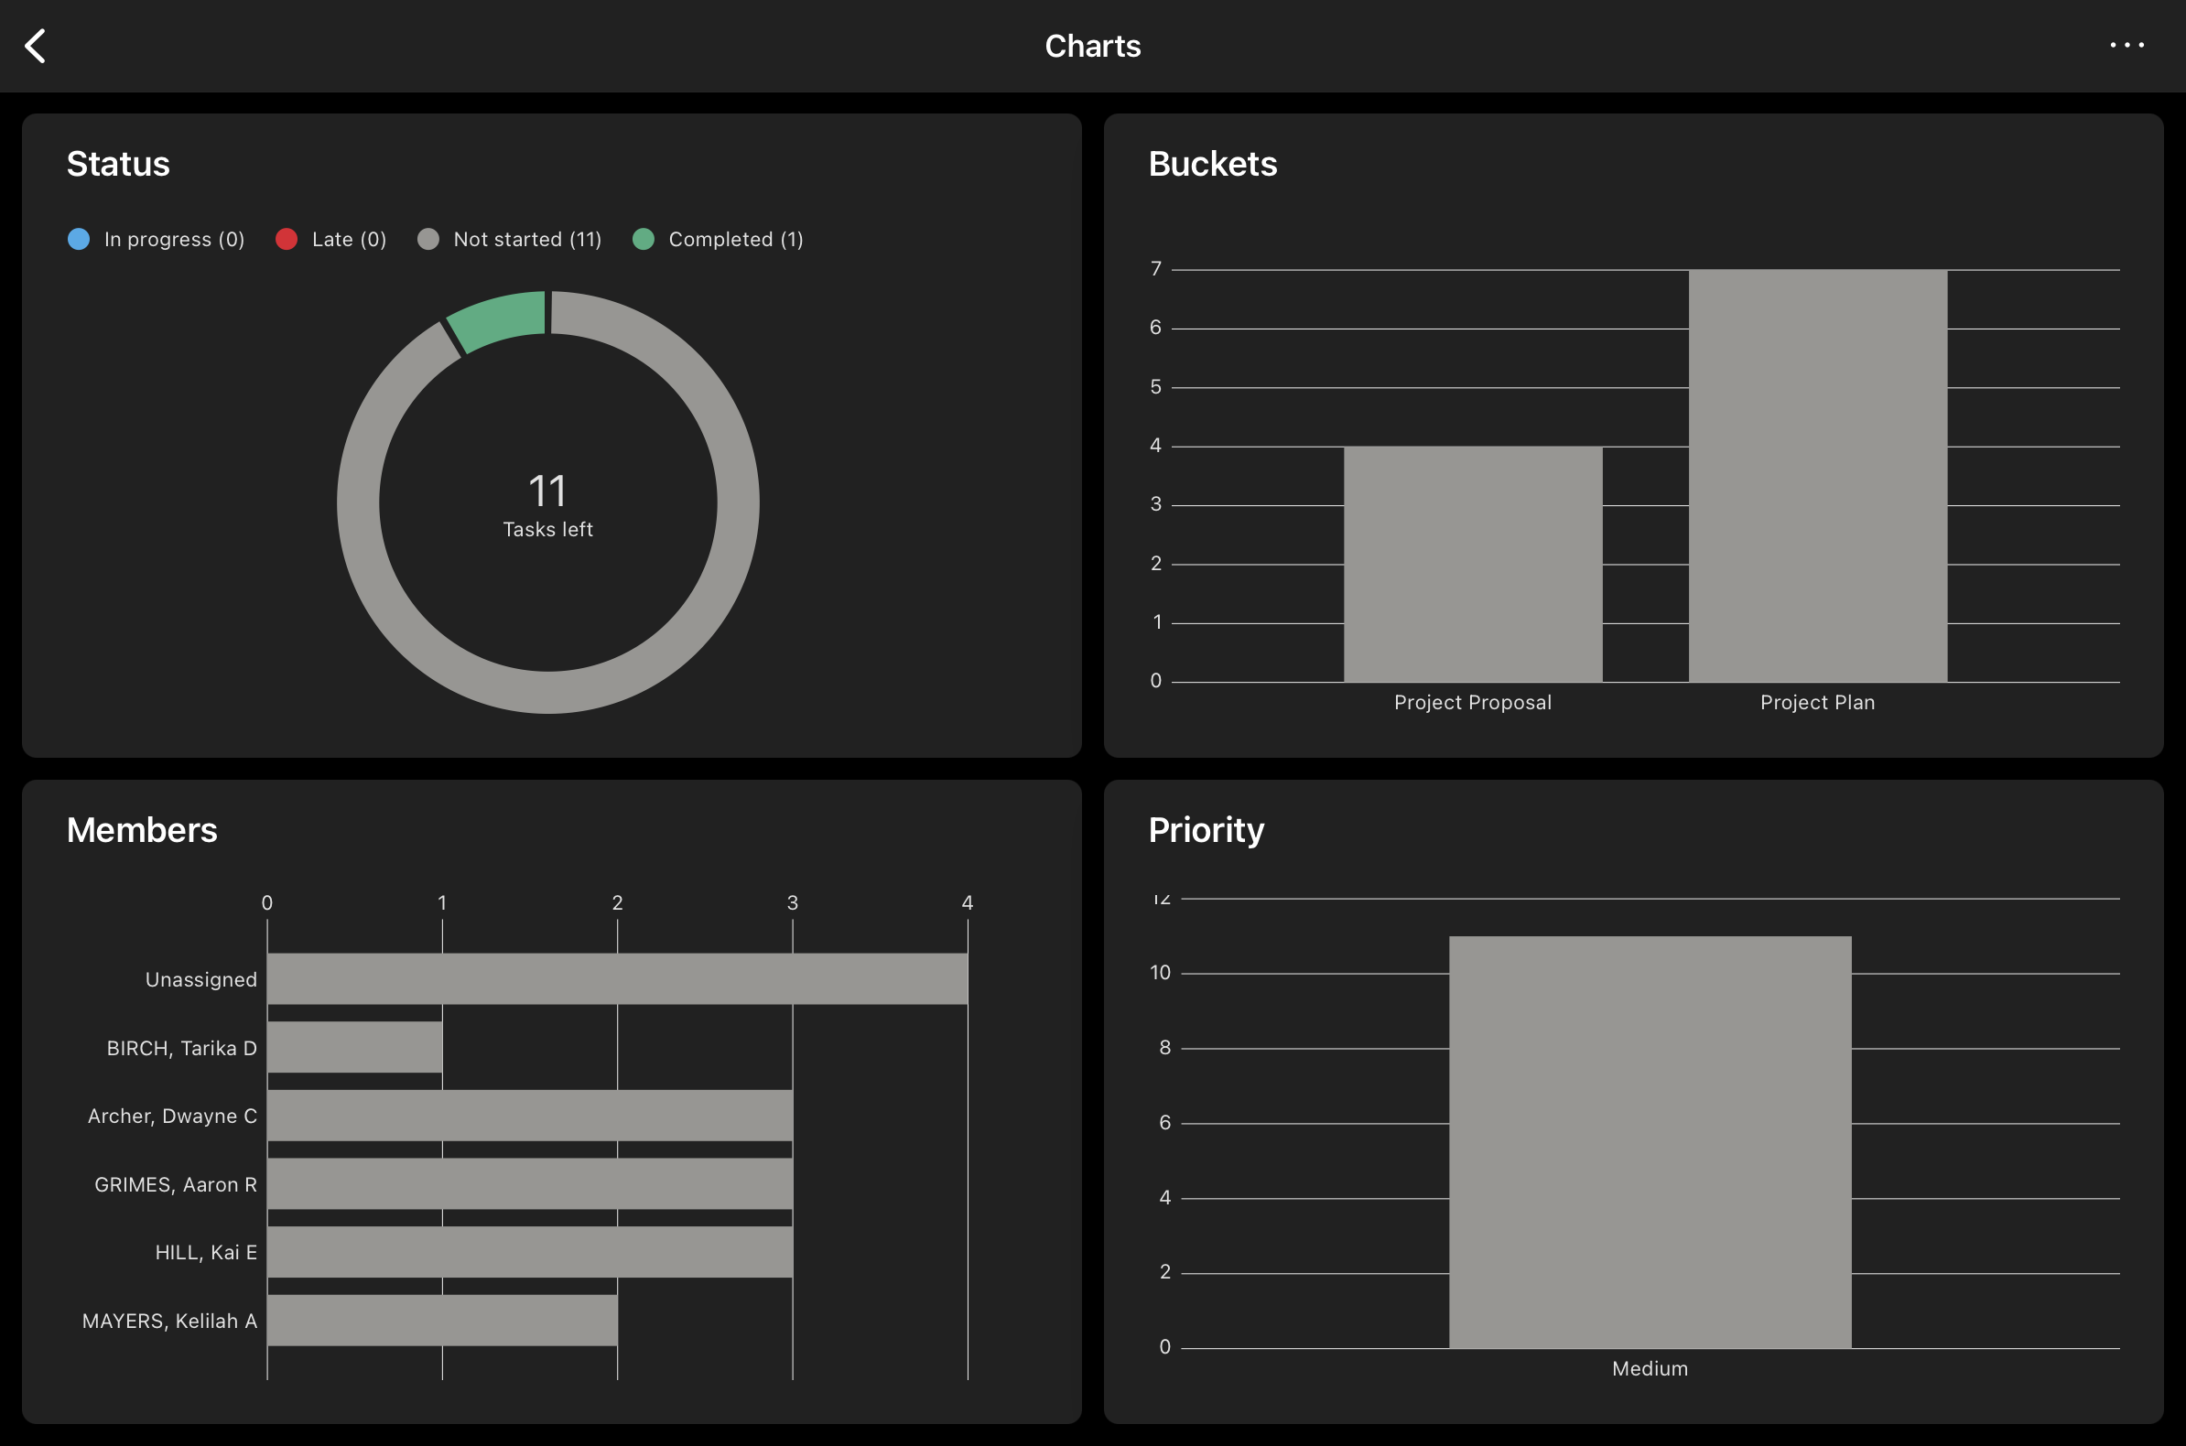

The metrics provided will allow the Project Manager to keep track of:

* Assigned Tasks
* In Progress Tasks
* Completed Tasks
* Incomplete Tasks
* Task Priority

1. **Shared Documentation**

All documentation will be shared on Microsoft Teams, allowing each individual to view changes in real time. This will provide a platform for:

* Informal reviews as changes are made
* Progress reviews throughout the week

1. **Communication Channels**

Members will communicate informally through the Microsoft Team and the WhatsApp Group. This will allow:

* Ease of communication outside of meetings
* Resolution of issues as they occur throughout the week
* Facilitation of brainstorming ideas as the project moves forward

1. **Key Performance Indicators**

The Key Performance Indicators outlined will allow for the monitoring of expected outcomes versus actual outcomes throughout the duration of the project.

## Key Performance Indicators (KPI)

**Project Progress**

Given the time constraints, one of the key factors that needs to be monitored is the overall progression of the project. The completion of project tasks and milestones will be measured against the outlined project schedule. The variation between estimated deadlines and actual milestones/deliverables will be used to monitor the timeliness of the project, allowing the Project Manager to determine whether or not the project is on track. This consistent monitoring will allow the Project Manager to course correct in the event that the estimated and actual timelines begin to vary too significantly.

**Appointments Missed**

After the skill has been implemented, a key indicator of the success of the project would be the number of missed appointments at O.P.S. If the number of missed appointments experiences a significant drop, the project will have successfully completed its objectives.

## Report Strategy

To facilitate effective communication and progress tracking in this project, a comprehensive reporting strategy will be implemented. The key elements of this reporting strategy are as outlined below.

**Oral Reports**

Oral reports will serve as a platform for communication and feedback between the members of the team. This form of reporting will be critical to effective communication when the time constraints of the project are considered. It will facilitate the real-time transmission of key information which is critical to the project. These reports will be delivered in the following formats:

1. Weekly Team Meetings
2. Status Updates via Informal Communication Channels

**Written Reports**

Written reports will be maintained in the form of a project logbook, providing a record of the project’s activities. This logbook will include:

1. Meeting Records
2. Milestones and Activity Updates
3. Project Updates
4. Resource Allocation & Availability Status

## Documentation Strategy

The project will produce a combination of internal and external documentation as a part of the project’s deliverables. Provided below is a brief description of the documentation which will be produced at different phases of the project.

